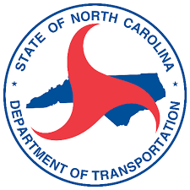

Anson County
Comprehensive Transportation Plan
April 11, 2022

- Introductions
- What is a CTP? Presentation
- CTP Steering Committee
  - Final Committee Member List
  - Handbook
  - Roles and Responsibilities
- Base and Future Year Discussion
- Anson County Travel Demand Model Presentation
- Public Involvement Introduction
  - How it will be carried out?
  - What is your role?
- Identification of Studied Roads
- Future Meetings
  - Meeting frequency
  - Scheduled dates/times
- Wrap Up

